
Yedi Risdianto | 200511033 | TI20D
Tugas 3 : Membuat aplikasi konversi celcius, Fahrenheit dan reamur

- Konversi Reamur ke Celcius, Fahrenheit, dan Kelvin

Source Code :

Public Class ConvertReamur
Private Sub btnConvert_Click(sender As Object, e As EventArgs) Handles btnConvert.Click

Dim R, C, F, K As Decimal
R = CDec(txtReamur.Text)
C = ToCelcius(R)
F = ToFahrenheit(R)
K = ToKelvin(R)

txtCelcius.Text = Str(C)
txtFahrenheit.Text = Str(F)
txtKelvin.Text = Str(K)
End Sub

Private Function ToCelcius(suhu As Decimal) As Decimal
Dim C As Decimal
C = (5 / 4) * suhu
Return C
End Function

Private Function ToFahrenheit(suhu As Decimal) As Decimal
Dim F As Decimal
F = (9 / 4) * suhu + 32
Return F
End Function

Private Function ToKelvin(suhu As Decimal) As Decimal
Dim K As Decimal
K = (5 / 4 * suhu) + 273
Return K
End Function

End Class

Hasil Program Konversi Reamur ke Celcius, Fahrenheit, dan Kelvin:

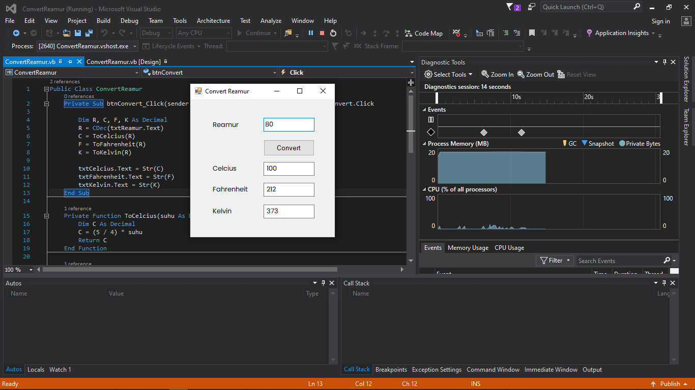

- Konversi Kelvin ke Celcius, Fahrenheit, dan Reamur

Source Code :

Public Class ConvertKelvin
Private Sub btnConvert_Click(sender As Object, e As EventArgs) Handles btnConvert.Click

Dim K, C, F, R As Decimal
K = CDec(txtKelvin.Text)
C = ToCelcius(K)
F = ToFahrenheit(K)
R = ToReamur(K)

txtCelcius.Text = Str(C)
txtFahrenheit.Text = Str(F)
txtReamur.Text = Str(R)

End Sub

Private Function ToCelcius(suhu As Decimal) As Decimal
Dim C As Decimal
C = suhu - 273
Return C
End Function

Private Function ToFahrenheit(suhu As Decimal) As Decimal
Dim F As Decimal
F = 9 / 5 * (suhu - 273) + 32
Return F
End Function

Private Function ToReamur(suhu As Decimal) As Decimal
Dim R As Decimal
R = 4 / 5 * (suhu - 273)
Return R
End Function

End Class

Hasil Program Konversi Fahrenheit ke Reamur :

